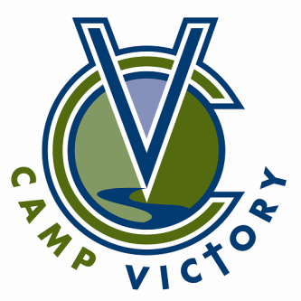
2021 16TH Annual

Camp Victory Benefit Golf Tournament

Friday June 4, 2021, Maple Valley

Making summer camp possible for at-risk and high needs youth

www.campvictory.com

The annual Camp Victory Benefit Golf Tournament is a special event to raise money for the Camp Victory ULEAD Scholarship Fund. Funds raised from this event will directly benefit children who do not have the means to attend and experience the wonder of summer camp on their own. These funds also go to help provide camp opportunities with organizations such as the Friendship Place, Boys and Girls Club of Rochester, Family and Children’s Center of Rochester, Olmsted Community Services, Rochester Y Mentors, Bolder Options, and other community agencies.

The Golf Tournament is a fun and enjoyable four person best shot played on the beautiful fairways and greens at Maple Valley Golf Course.

The Camp Victory Golf Committee thanks you in advance for your support. Because you care and invest, many young campers will have an opportunity to experience God’s creation, to build real and lasting relationships in a healthy and safe environment, and to experience an unforgettable, fun-filled week.

SPONSORSHIP LEVELS AND BENEFITS Camp Victory is a nonprofit 501(c)3 organization. All contributions are tax deductible.

PREMIER TOURNAMENT SPONSOR $5,000
- Speaking opportunity during the dinner/program
- Display your banner on front lawn of club house
- Company logo displayed on table tent at dinner.
- One Contest hole TEE SPONSOR sign at tee box
- Golf for twelve [three (3) teams of four (4)] with carts and dinner at the Golf Tourmament
- Premier Sponsor location of logo on website, tournament program, and other promotional materials

TOURNAMENT SPONSOR $2,500
- Display your banner on front lawn of club house
- Company listed on table tent at dinner.
- One TEE SPONSOR sign at tee box
- Golf for eight [two (2) teams of four (4)] with carts and dinner at the Golf Tournament
- Logo on website, tournament program, and other promotional materials
- Sponsor signs on golf carts

REFRESHMENT CART SPONSOR $1500
- Exclusive Signage/Advertising on roaming cart and tee
- Golf for four [one (1) team of four (4)] with cart and dinner at the Golf Tournament
- Logo on website, tournament program, and other promotional materials

CLUB SPONSOR $1000
- One sponsor sign on a number of carts and practice putting green
- Golf for four [one (1) team of four (4)] with cart and dinner at the Golf Tournament
- Logo on website, tournament program, and other promotional materials

TEE SPONSOR $500
- Sponsor sign on tee box
- Golf for four [one (1) team of four (4)] with cart and dinner at the Golf Tournament
- Listed on website, tournament program, and other promotional materials

Please provide the following information along with your contribution and mail to:
Golf Tournament Questions:
Camp Victory Ministries, Inc., 507-843-2329
58212 403rd Ave. lingentling@camppvictory.com
Zumbro Falls, MN 55991

Company Name (for hole sign): |  | Phone :
Contact Name: |  | Fax :
Address:
City/State/Zip:
Email Address:

