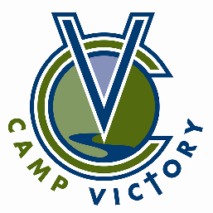
21st Annual Camp Victory Scholarship Golf Tournament
Friday, June 5, 2026

REGISTRATION FORM
Mail to:
CV Golf Tournament
58212 403rd Ave
Zumbro Falls, MN 55991

TEAM SPONSOR (if applicable) or Team Name

________________________________________________________________________

Team Contact Person:
Name: __________________________________________________________________
Phone: __________________________________________________________________
Address: ________________________________________________________________
City: ___________________________ State: ________________ Zip: _______________
Email: __________________________________________________________________

Golfing Fee Enclosed: ____________________________________________________________
Single: $125 Foursome: $500 Sponsorships (see sponsorship form on website)

Golfers on your Team with Email Addresses:
2. ____________________________________________________________________________
3. ____________________________________________________________________________
4. ____________________________________________________________________________

